***CREATION OF BASE TABLE AND DML OPERATIONS***

***Name : Renuga Devi .K***

***Roll No : 231901041***

Create table my_employee(ID number(4),Last_name varchar (25),First_name varchar(25),userid varchar(25),salary number(9,2));

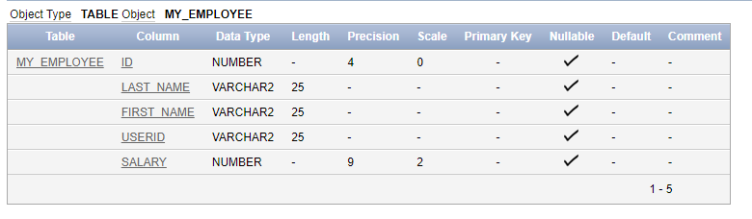

Insert into my_employee values(1, ‘patel’,’ralph’,’rpatel’,895),(2,’dancs’,’betty’,’bdancs’,860),

(3,’Biri’,’Ben’,’bbri’,1100),(4,’Newman’,’chad’,’Cnewman’,750);

Select *from my_employee

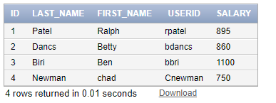

delete from my_employee where first_name='Betty';

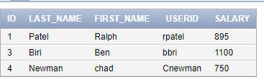

delete from my_employee where ID=4;

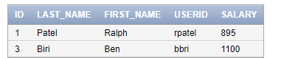

commit;

update my_employee set last_name='Drexler' where ID=3;

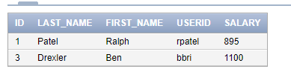

update my_employee set salary=1000 where salary<900;

